**Placement Empowerment Program**

***Cloud Computing and DevOps Centre***

Deploy your static website using Github Pages : Host your local Git repository’s static website directly using Github pages

Name: Jaswanth Saravanan

Department: ADS



**Introduction :**

GitHub Pages is a static site hosting service designed to publish your projects directly from a GitHub repository. It allows developers to showcase their work, create personal websites, or host documentation in an efficient, free, and straightforward way.

**Overview :**

This project demonstrates how to deploy a static website using GitHub Pages. Starting with the basics of setting up a GitHub repository, we’ll explore each step required to host a functional static website. This includes initializing a Git repository, pushing files to GitHub, and configuring GitHub Pages for deployment.

**Key Features of GitHub Pages**:

* Free hosting for public repositories.

* Support for static files (HTML, CSS, JavaScript).

*Easy integration with version control through Git.

Step by Step Overview:

Step 1 :

Make a HTML code According to your need , to host a web page by using it .

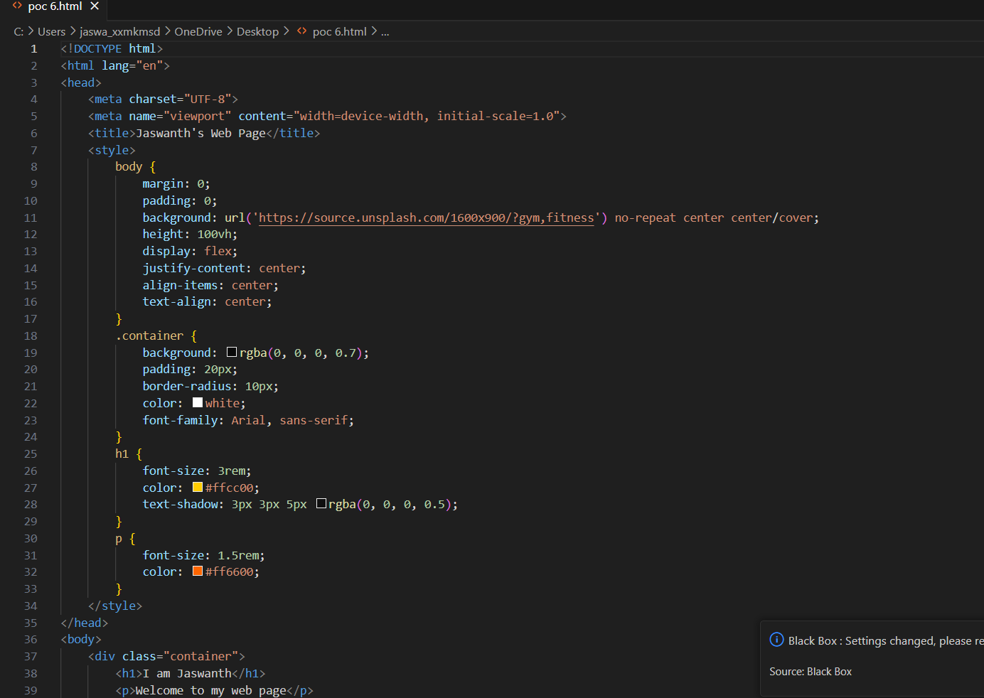

Step 2:

Save the code where you want in your System by using .html (example :index.html)

Step 3 :

Open up your Github and Create a new repository , there are two ways by which you can upload your file or create a new file .

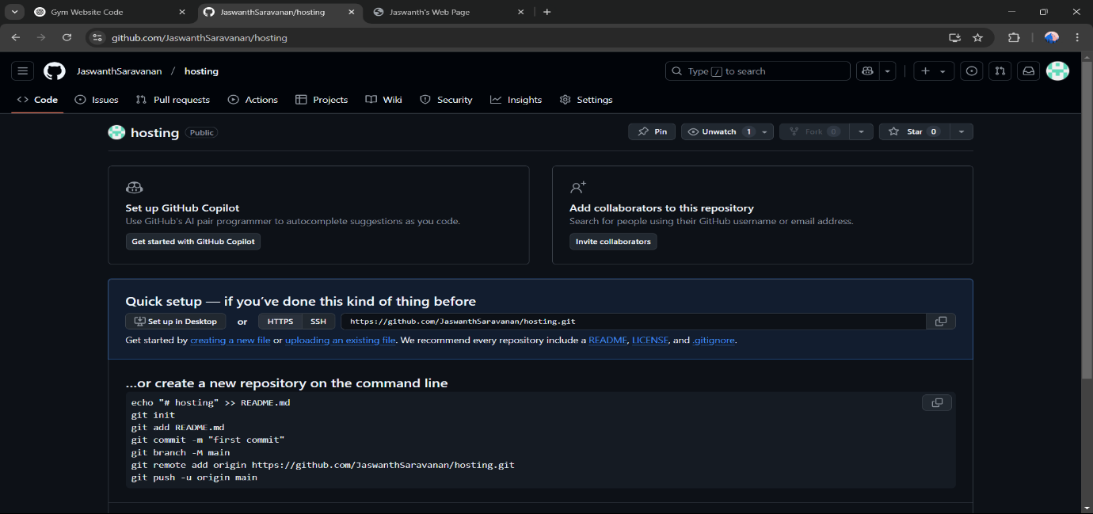

Step 4:

Move to the settings page to access setting

Step 5 :

In the Settings page , change the branch to main and Save it .

Step 6 :

Wait for few minutes , so that the link will be appear as :

https://<your-username>.github.io/<your-repository>

Step 7:

Then visit the link then the website will be hosted on your local System .



Outcome :

By completing this PoC of deploying a static website using GitHub Pages, you will:

1. Successfully create and configure a GitHub repository for your project.
2. Initialize a Git repository in your local project folder and link it to GitHub.
3. Upload your static website files (HTML, CSS, JavaScript) to GitHub.
4. Enable GitHub Pages in the repository settings to host your static website.
5. Access your static website live on the web via a GitHub Pages URL.
6. Gain hands-on experience with Git commands like git init, git add, git commit, git remote add, and git push.
7. Understand the process of hosting a static site for free using GitHub Pages.